Lab 7.1 Working with Nagios Monitoring Tool

This section will show you how to install Plugin in Nagios Monitoring tool

This lab has 6 sub-sections:

* + 1. Download Nagios plugin source code
    2. Open Admin console of Nagios to install plugin
    3. Validate installation of Nagios plugin
    4. Add node details in Nagios portal
    5. Install specified Nagios agent on node machine
    6. Validate node details from Nagios dashboard

**Step 7.1.1:** Download Nagios plugin source code

Install Nagios for Enterprise Edition

You need to first run an interactive shell as root using the following command:

sudo -i

Now, use the command below to install Nagios.

curl <https://assets.nagios.com/downloads/nagiosxi/install.sh> | sh

Once the installation is complete, you should see a message similar to the one below:

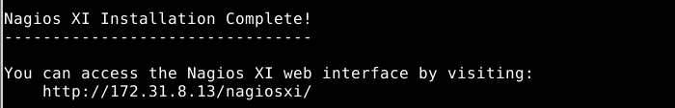

Type the URL below in your browser:

http://(ip address)/nagiosxi

The following page will open.

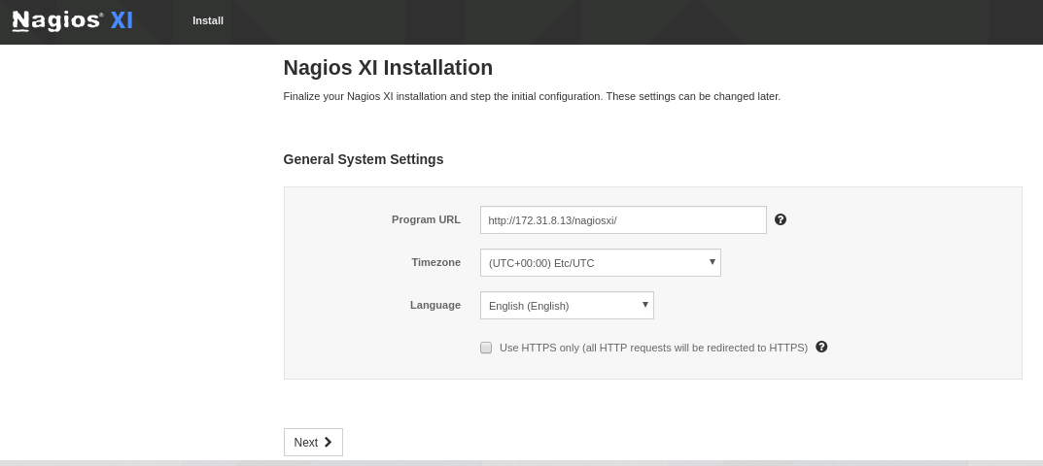

Click on **“Next.”**

Change the password and click on **“Finish Install.”**

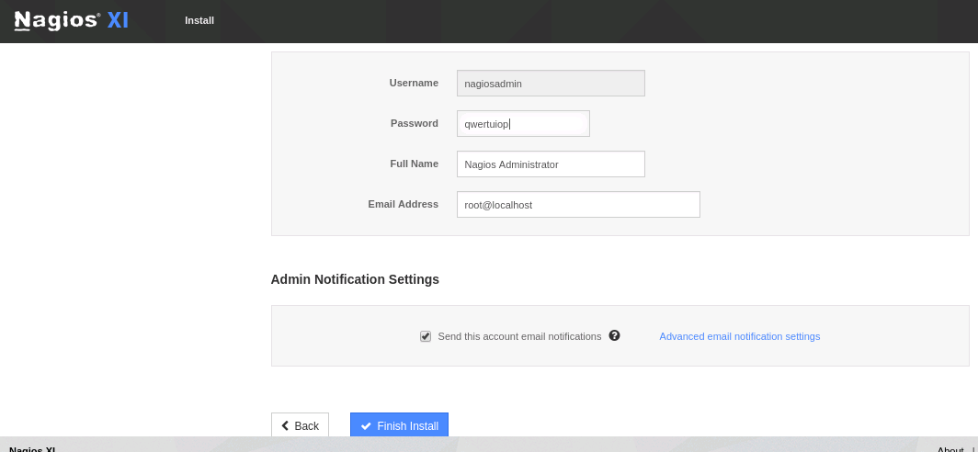

Now, log in to Nagios using your username and password.

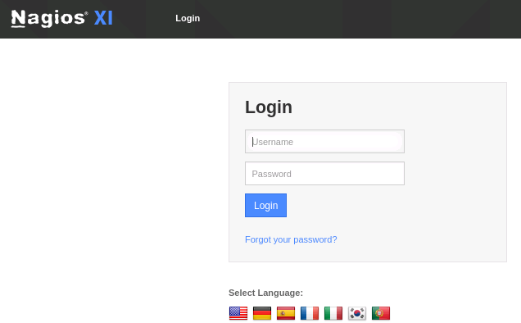

Now, accept the license agreement.

Download Nagios plugin from Nagios exchange website.

Download countdown_to_date.zip file using the URL below and extract it:

<https://exchange.nagios.org/directory/Plugins/Others/countdown_to_date/details>

**Step 7.1.2:** Open Admin console of Nagios to install plugin

Access Nagios admin page and install plugin.

Login to Nagios XI.

Installing a new plugin in Nagios XI is very simple. Navigate to **Admin > System**

**Extensions > Manage** **Plugins.**

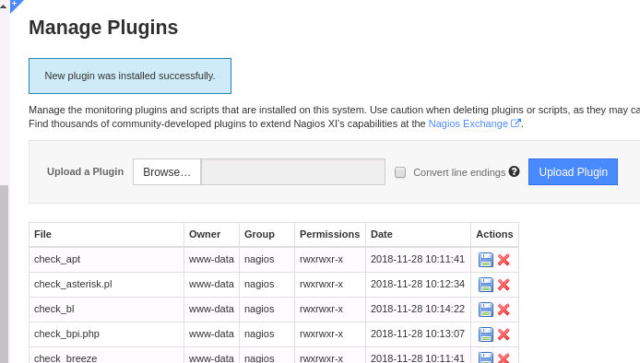

Click on “**Browse.”**

Go to the unzipped folder of countdown_to_date. You will find a file named “**countdown_to_date.php**” in it. Upload that file. Once done, you will see the following message.

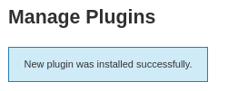

**Step 7.1.3:** Validate installation of Nagios plugin

Go to /usr/local/nagios/libexec using the following command:

cd /usr/local/nagios/libexec

Validate that the plugin has been uploaded.

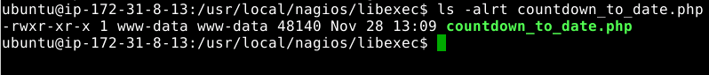

**Step 7.1.4:** Add node details in Nagios portal.

Click on “**Configure your monitoring setup.”**

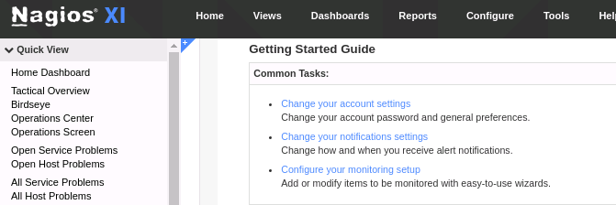

Now, click on “**Start Monitoring Now.”**

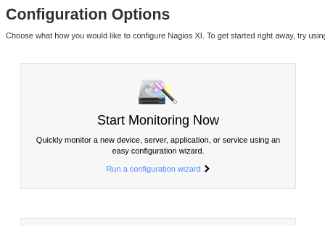

Search for “**Linux Server**” and click on it.

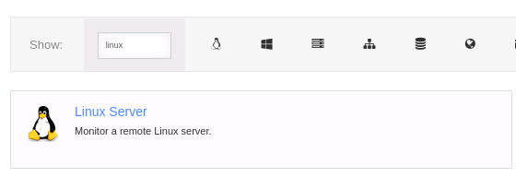

Fill in your IP address and choose “**Linux Distribution**” as “**Ubuntu.**”

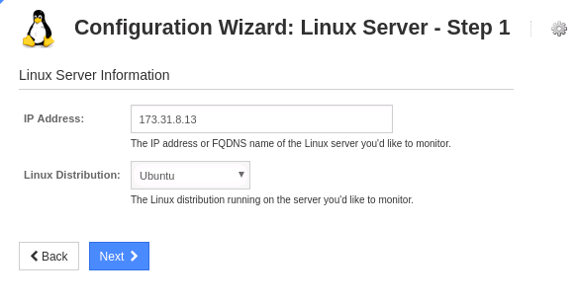

Click on “**Next.**”

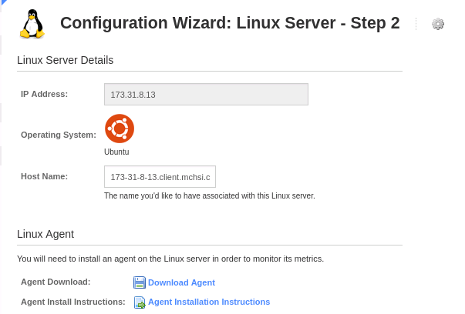

**Step 7.1.5:** Install specified Nagios agent on node machine

Download Nagios agent steps. Proceed with the installation of agent on node machine. You will then add agent to Nagios Tool.

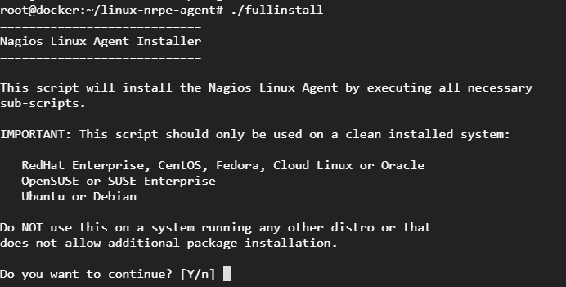

Once this is done, you can access the node details from the monitoring dashboard.

**Step 7.1.6:** Validate node details from Nagios dashboard

Validate if node added to Nagios properly or not:

